Field Hockey Drills/Exercise Workouts
From: Pace University Field Hockey

DRILLS & COMPETITION

1. Cone dribbling ideas
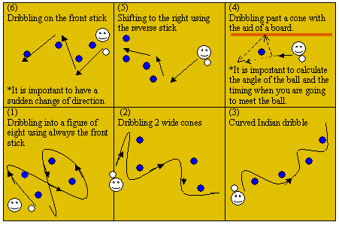

2. Straight line of cones spread out – pulls at each cone
- Right pull
- Left pull
- C dodge
- Pull left lift right
- Pull right lift left
- Slalom
- Indian dribble
- Spin dodges

3. Ladder workouts
- two feet in each space, go through ladder holding stick balancing ball on stick
- two feet in each space, bouncing ball up and down on stick

4. Yard stick
- standing still Indian dribble – count how many times you can go back and forth in 60 seconds – try and beat score each day.

5. Aerial competitions
- how many times can you bounce ball up and down on stick?
- how long can you balance ball on stick?
- bounce ball on all sides of the stick without it touching the floor

CHALLENGES

- Stick balance challenge
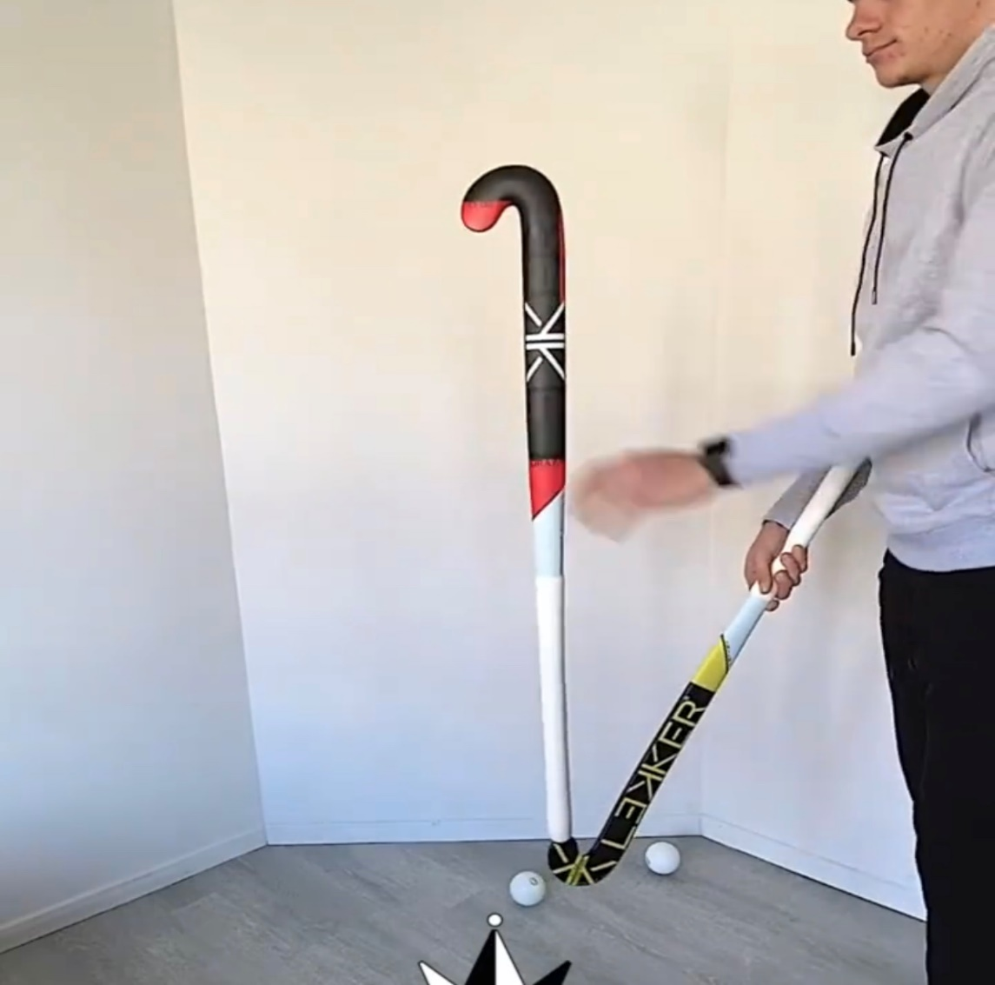

- grab 2 hockey sticks
- hold one stick on the edge of the hook of another one

2. Toilet paper challenge
- Grab a toilet paper and stick
- Try to do ten touches in the air

EXTRA ** Hockey drill videos: Instagram – “complete hockey coaching”

FUN CARDIO
